姓名 | 胡相南
教育与工作经历 | 2025–Present | Southern University of Science and Technology (SUSTech) | Undergraduate Student in Automation
电子邮箱 | 12510438@mail.sustech.edu.cn
个人照片 | 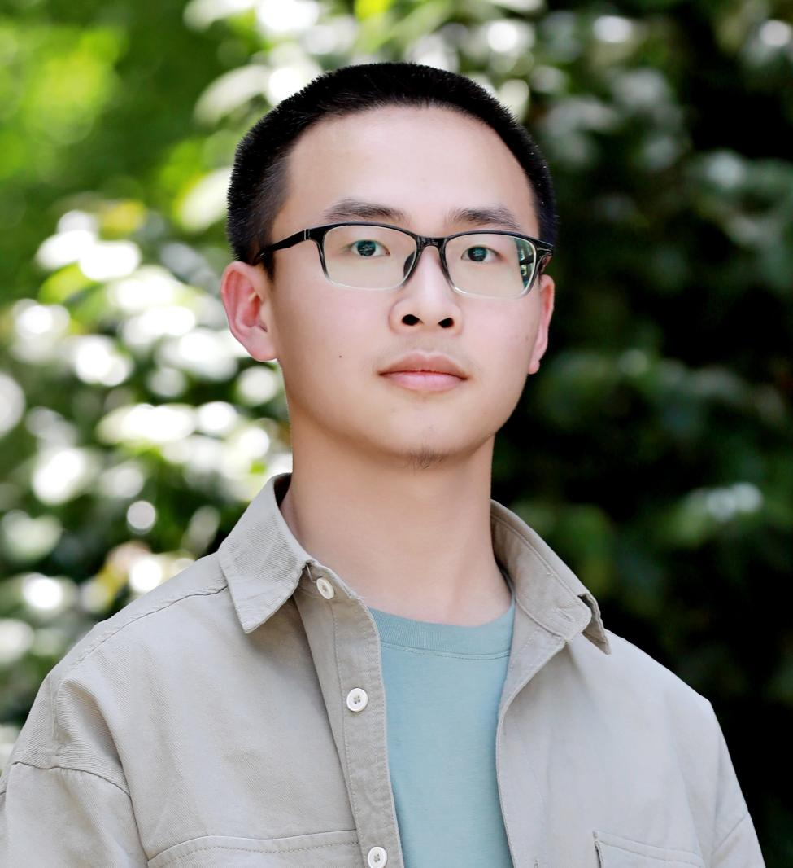
研究领域 | Embodied Intelligence, Bio-inspired Robotics, Adaptive Robot Control
自我介绍 | Hi, I’m 胡相南, an Automation undergraduate student at Southern University of Science and Technology (SUSTech). I’m passionate about robotics and aim to become a full-stack robotics engineer. Currently, I’m continuously learning and improving my skills across robotics, software, and hardware development. Any feedback or guidance is greatly appreciated!
论文发表情况
填写参考：https://bird-lab.org/people

